2001: a cave odyssey

23rd Biennial Conference of the Australian Speleological Federation

28 December 2000 – 2 January 2001,

All Saints College, Bathurst, New South Wales, Australia

Proceedings

edited by
Cathy Brown

Australian Speleological Federation, Inc. PO Box 388, Broadway, NSW 2007

Published in Canberra, 2002, by the Australian Speleological Federation, Incorporated.
PO Box 388, Broadway, NSW 2007
© Copyright 2002. All individual submissions in this publication are Copyright by the respective authors or organisations, unless otherwise acknowledged.
© Copyright 2002. All other parts of this publication are copyright by the Australian Speleological Federation Inc..
All rights reserved. No part of this publication may be reproduced in any form without written permission of the publishers or the authors concerned.

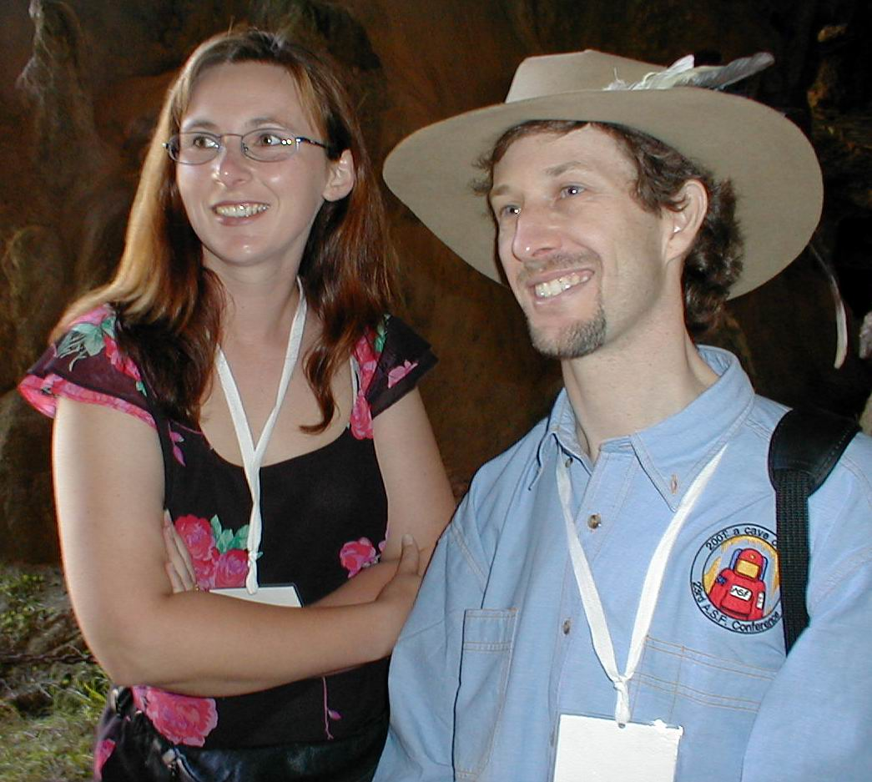
Jodie and Gus at Abercrombie Arthur Clarke

Conference Committee:
CONVENOR: Angus Macoun, RSS;
Secretary/Treasurer: Jodie Rutledge, NHVSS;
Safety: Mike Lake, SUSS etc; Equipment: Jason Goldstein, RSS; Liaison: Ernst Holland, JCRT;
ACTIVITIES: Ian Binnie, MUCG; Speleosports: Mark Westhorp, CTCC; Partners’ Programme: Joan Crabb, HCG; Post Conference Trip Co-ordinator: Walter Waener, ISS; Observatory/Abercrombie Trip: Cindy & Ray Pickard; Cave Rescue: Grace Matts, NSWCRG; Cliefden Trip: Denis Marsh, OSS; Yarrangobilly/Cooleman/Wombeyan Trips: Chris Bradley, CSS; Aboriginal Liaison: Peter Dykes, CWCG;
PROGRAMME Presentations/Posters/Timetable: Jill Rowling, SUSS etc;
Promotion/Sponsorship/Equipment Expo/ASF Executive Member: Joe Sydney, HCG;
Conference Web Site: Michael Rutledge, NHVSS; Merchandise Jenny Whitby, NHVSS;
PUBLISHING Guide Book/Art Catalogue/Programme: Evalt Crabb, HCG; Proceedings: Cathy Brown, CSS;
SITE: Jodie Rutledge; Art Show: Andy Lawrence, JCRT;
OTHERS: Gary Whitby, NHVSS; Anna Binnie, MUCG; Advisor/ASF Executive Member: John Dunkley, CSS; NSWSC Executive Member: Chris Norton, SUSS; NSWSC Executive Member: David Bennett, RSS;
with assistance from
Ted Reedy, JCRT; Mia Thurgate, JCRT; Steve Reilly, JCRT; June MacLucas, CEGSA; Malcolm Griggs, All Saints College; David Bragg, All Saints College; Garry Smith, NHVSS; Bruce Howlett, OSS; Darryl McDowell, RSS; Frank Colzato, photographer; Trevor Ethell, Shutter Bugs; Lyle Lynch, Fletchers Fotographics; Alan McRae, Eastman Camera House.
Apologies to anyone we have overlooked

Cover Photo: Tony Watson in 3M18 – Canyons cave at Murrindal. It was awarded equal second place in
Division 3, “Cavers”, in the Photography Competition at Bathurst. Taken by Brett Wakeman.

Contents

Sponsors page …………………………………………………………………………….4
Current exploration in the Junee-Florentine Area, Tasmania. – Jeff Butt………………...5
Hunting Signatures – Darryl McDowell…………………………………………………..8
JCRT State of the Environment Report – Andy Spate…………………………………. 11
Would we develop Imperial Cave Today? – Ernst Holland…………………………… 16
The Equilibrium Hydrogeochemistry of Davys Creek, Central NSW. - S.A. Lucas …...20
Bullita cave - Poster - Chris Bradley……………………………………………………31
Flood effects in McKeowns Valley and Mammoth Cave, Jenolan Caves, NSW -
C. Henry Shannon……………………………………………………………………….33
Criteria on selecting a cave for commercial wild adventure tours - Report on
Workshop - Nicholas White…………………………………………………………….39
Cave Aragonites of NSW - Jill Rowling………………………………………………...40
Cataloguing helictites & other capillary-controlled speleothems - Jill Rowling………..46

Art Technique Used in Speleo Art – June Maclucas …………………………………..57
Maps of Australian Caves and Karst - John Dunkley ……………………………….....67

Who was Edie Smith? - Norman Poulter OAM, Dr. Albert Goede……………………71

Scientific Publishing: where do cavers fit? - Susan White ……………………………..89
The Nullarbor - Fuel Stove Only? A Discussion Paper - Norman Poulter OAM ….…..94
Explorers, Surveyors, Missionaries and Travellers: the first chapter of Australian
speleological history 1788-1838 - John Dunkley …………………………………....96
Launching the ASF's Website - Mike Lake and Jill Rowling………………………….123
The ASF's Web-based National Karst Index Database: Implementation &
Implications - Michael Lake…………………………………………………………124
Sharing information on Speleothems & Cave Minerals: A Workshop - Jill Rowling....132
Tour Description: Orient Cave Mineralogical / Speleothem Tour - Jill Rowling……...141
Tour Description: Mineralogical tour of Chifley Cave, Jenolan - Jill Rowling……….141
Tour Description: Jubilee Cave Mineralogical / Speleothems Tour - Jill Rowling…....141
The Abercrombie Footprint: a report on the sighting of an anomaly
- Glenn Woodley………………………………………………………………………142
Borenore - An Escape from Cave Politicians - Paul Nelson…………………………143
SPELEO ART DOWN UNDER:
List of Art Work of ISSA & SPELEO-ART members ……………………………….144
Artist information………………………………………………………………….......148
Exploration of caves in northwestern Guangxi Province, SW China:
11th Britain-China Expedition, October 2000 – Arthur Clarke………………………154

